Supply List for Den Meetings

Meeting one:
You will need:
Paper
Crayons
Enough copies of the oath and law handouts so each scout can have one. The handout is provided on the next page.
Cub Scout Bobcat Requirements:
1. Learn and say the Scout Oath, with help if needed.
2. Learn and say the Scout Law, with help if needed.
3. Show the Cub Scout sign. Tell what it means.
4. Show the Cub Scout handshake. Tell what it means.
5. Say the Cub Scout motto. Tell what it means.
6. Show the Cub Scout salute. Tell what it means.
7. With your parent or guardian, complete the exercises in the pamphlet How to Protect Your Children from Child Abuse: A Parent’s Guide

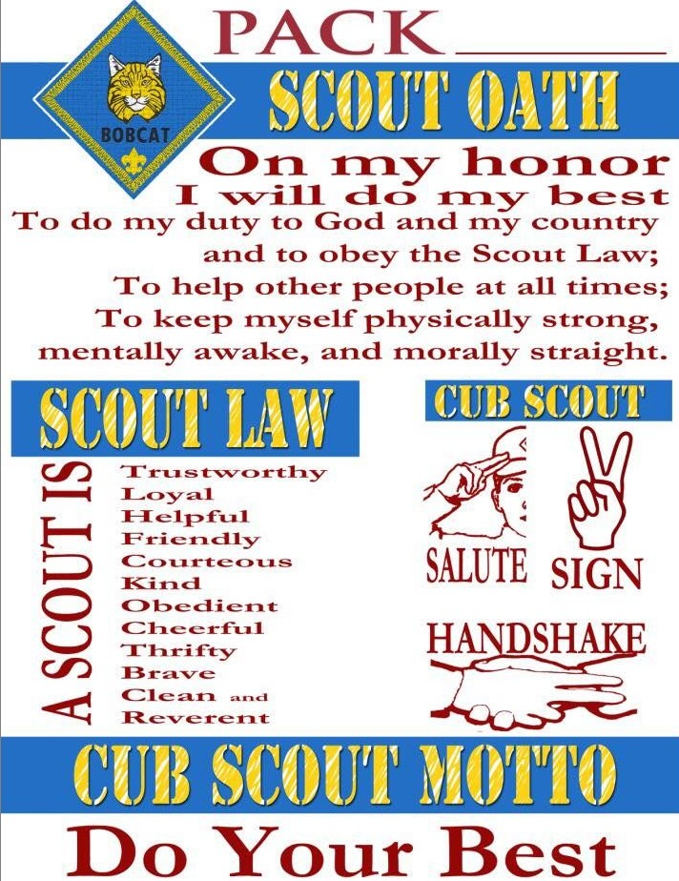

Meeting Two:
You will need:
Large Sheet of Paper / Poster board
Pen /pencil

Meeting Three:
You will need:
Small ball
Glitter
Place to wash hands
Disposable bag big enough to shake ball in

Meeting Four:
You will need:
Measuring tape
Stopwatch / Phone
Printed Copy of chart on next page
Name | Jumping Jacks | Push Ups | Sit Ups | 25 Yard Sprint | Scouts Choice

Meeting Five:
You will need:
Enough copies for each scout of the mad lib and song page.

Mad Lib: Moody Kitty
Just like a (noun)__________________, a cat can have a lot of different moods. Use this guide to decode your cat’s mood! Is kitty pressing her paws into a _(noun)__________________ and (verb)__________________ really loud? That means she’s very (verb)____________________. If Fluffy is growling or (verb)________________, she needs some space. Don’t try to play with her now or she might bite your (MISC)________________! A scared cat will have ears that are (adjective)________________, an arched (MISC)__________________, and a big (adjective)_______________ tail. A/AN(MISC) __________________ between her legs and (adjective)_______________ eyes mean Chloe’s feeling nervous. When Pumpkin wants to play, he’ll get low to the (noun)______________ with his (MISC)__________________ in the air and pounce! The more attention you give to your feline (noun)________________, the more you’ll be able to tell how she’s (verb)_________________.
Song: Do Your Ears Hang Low?
Tune: “Turkey in the Snow”
Do your ears hang low
Do they wobble to and fro
Can you tie them in a knot
Can you tie them in a bow
Can you throw them o’er your shoulder,
Like a Continental soldier?
Do your ears --- hang --- low?

Meeting Six:
You will need:
Measuring type
Phone or stopwatch
Log from Meeting Four

Meeting Seven:
You will Need:
Copies of family tree
Crayons
pencils
Blank Paper/ Construction paper

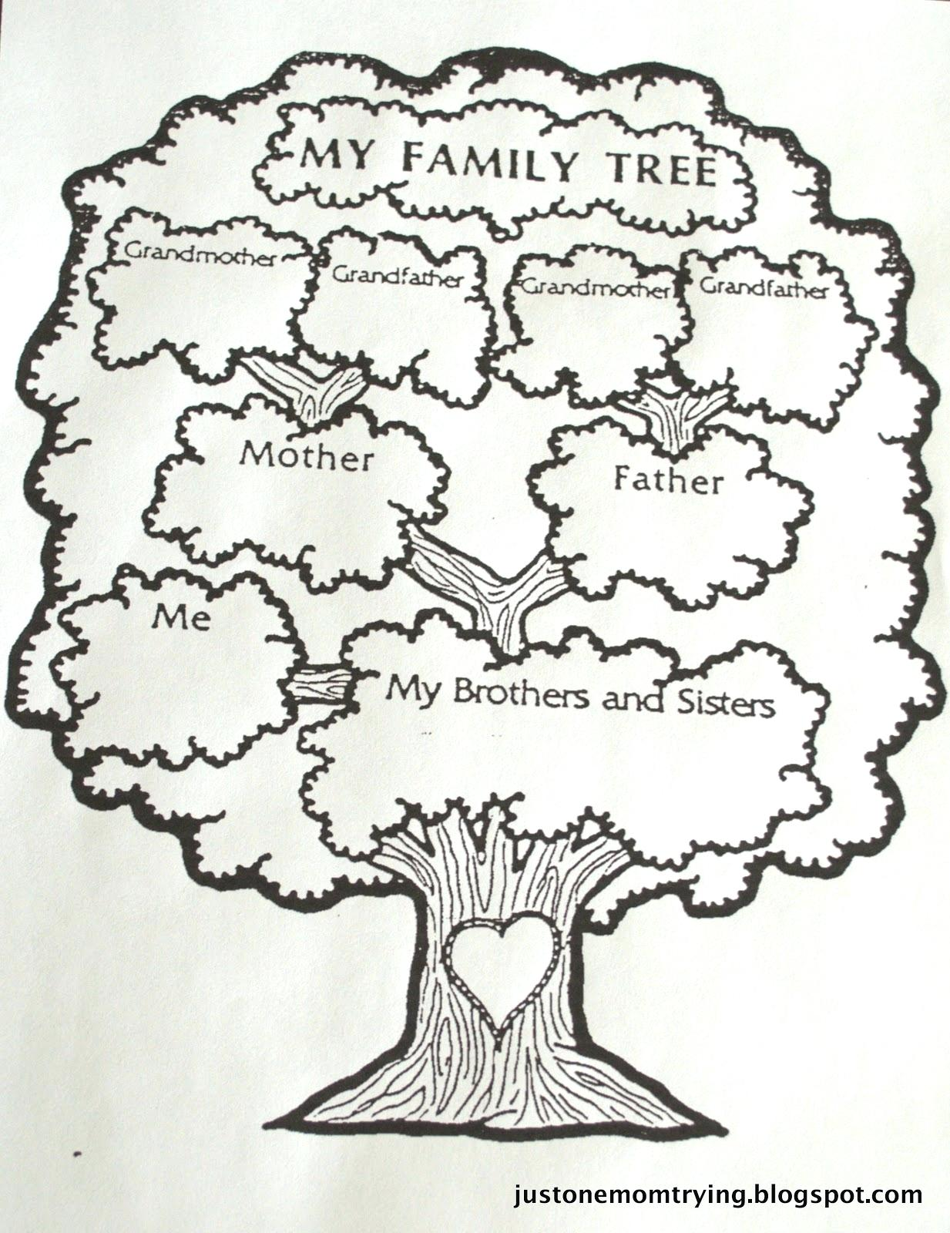

Meeting Eight:
You will need:
Cardboard tubes
Crayons
Wax Paper
Scissors
Beads/ Rice/ Dried Beans
Rubber Bands

